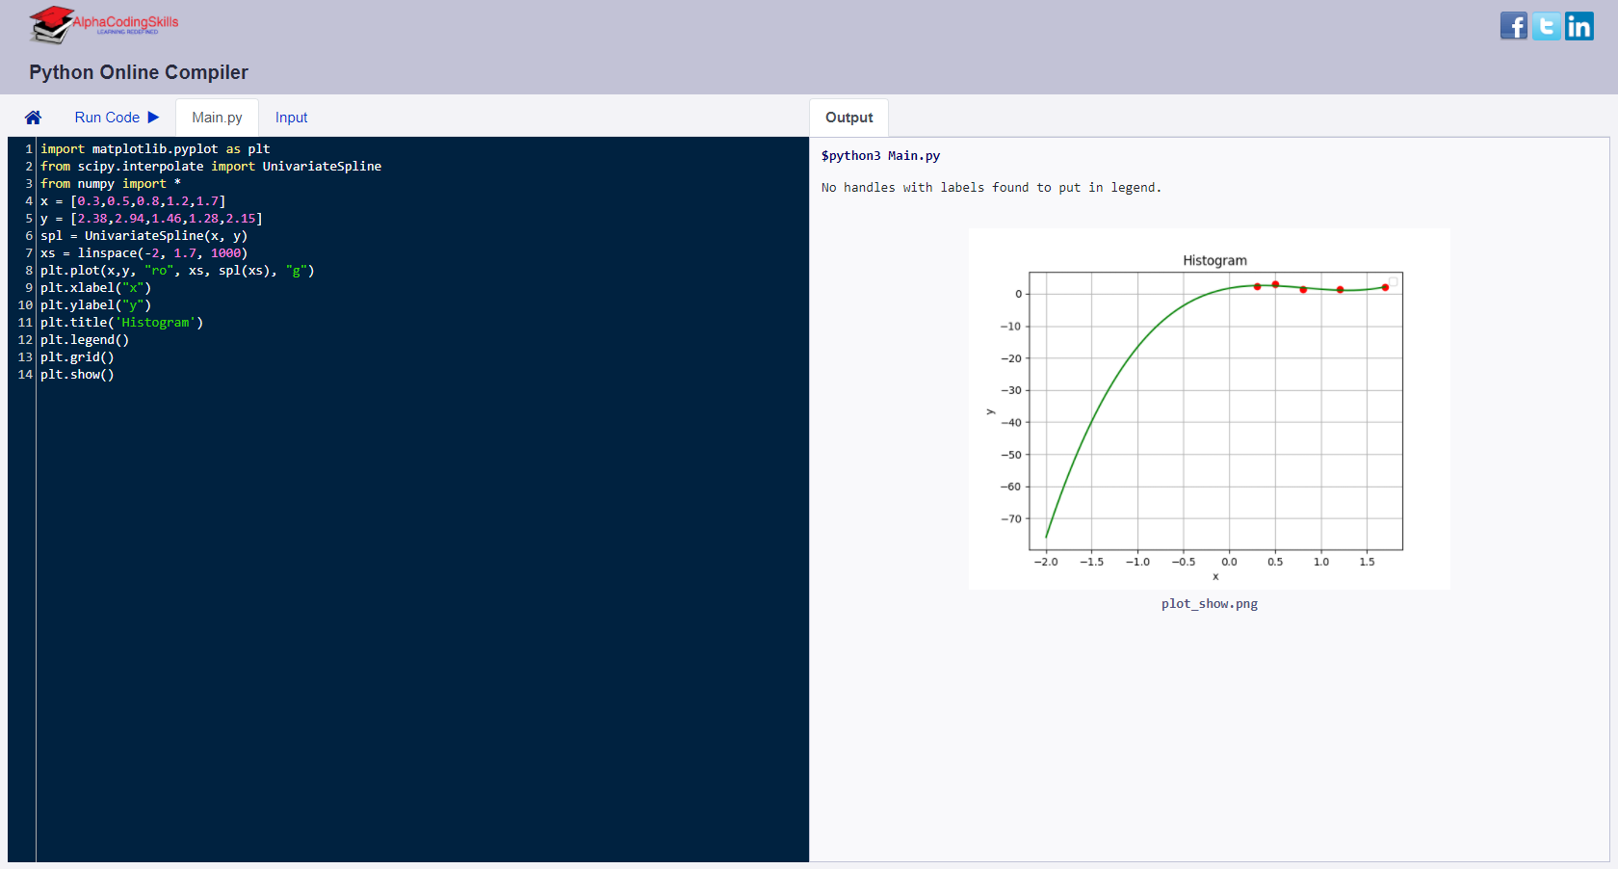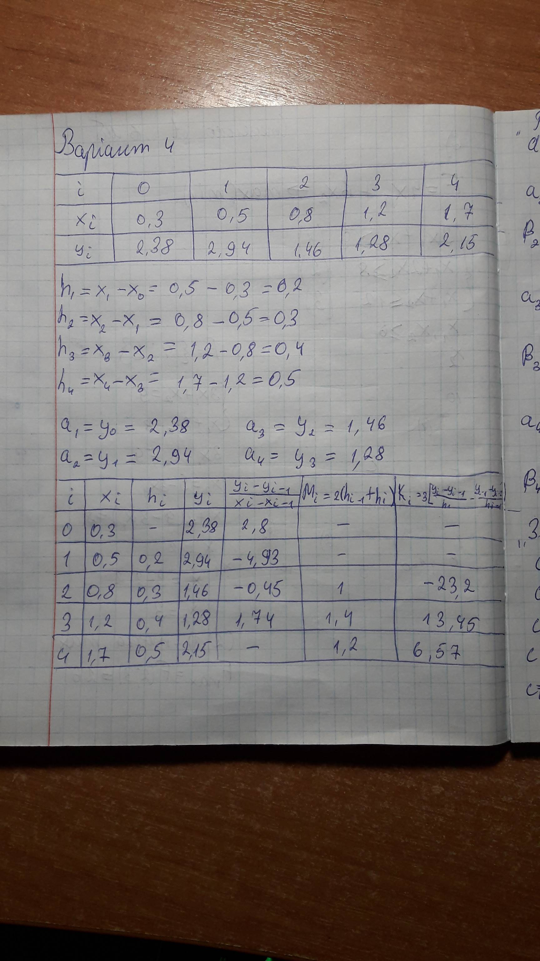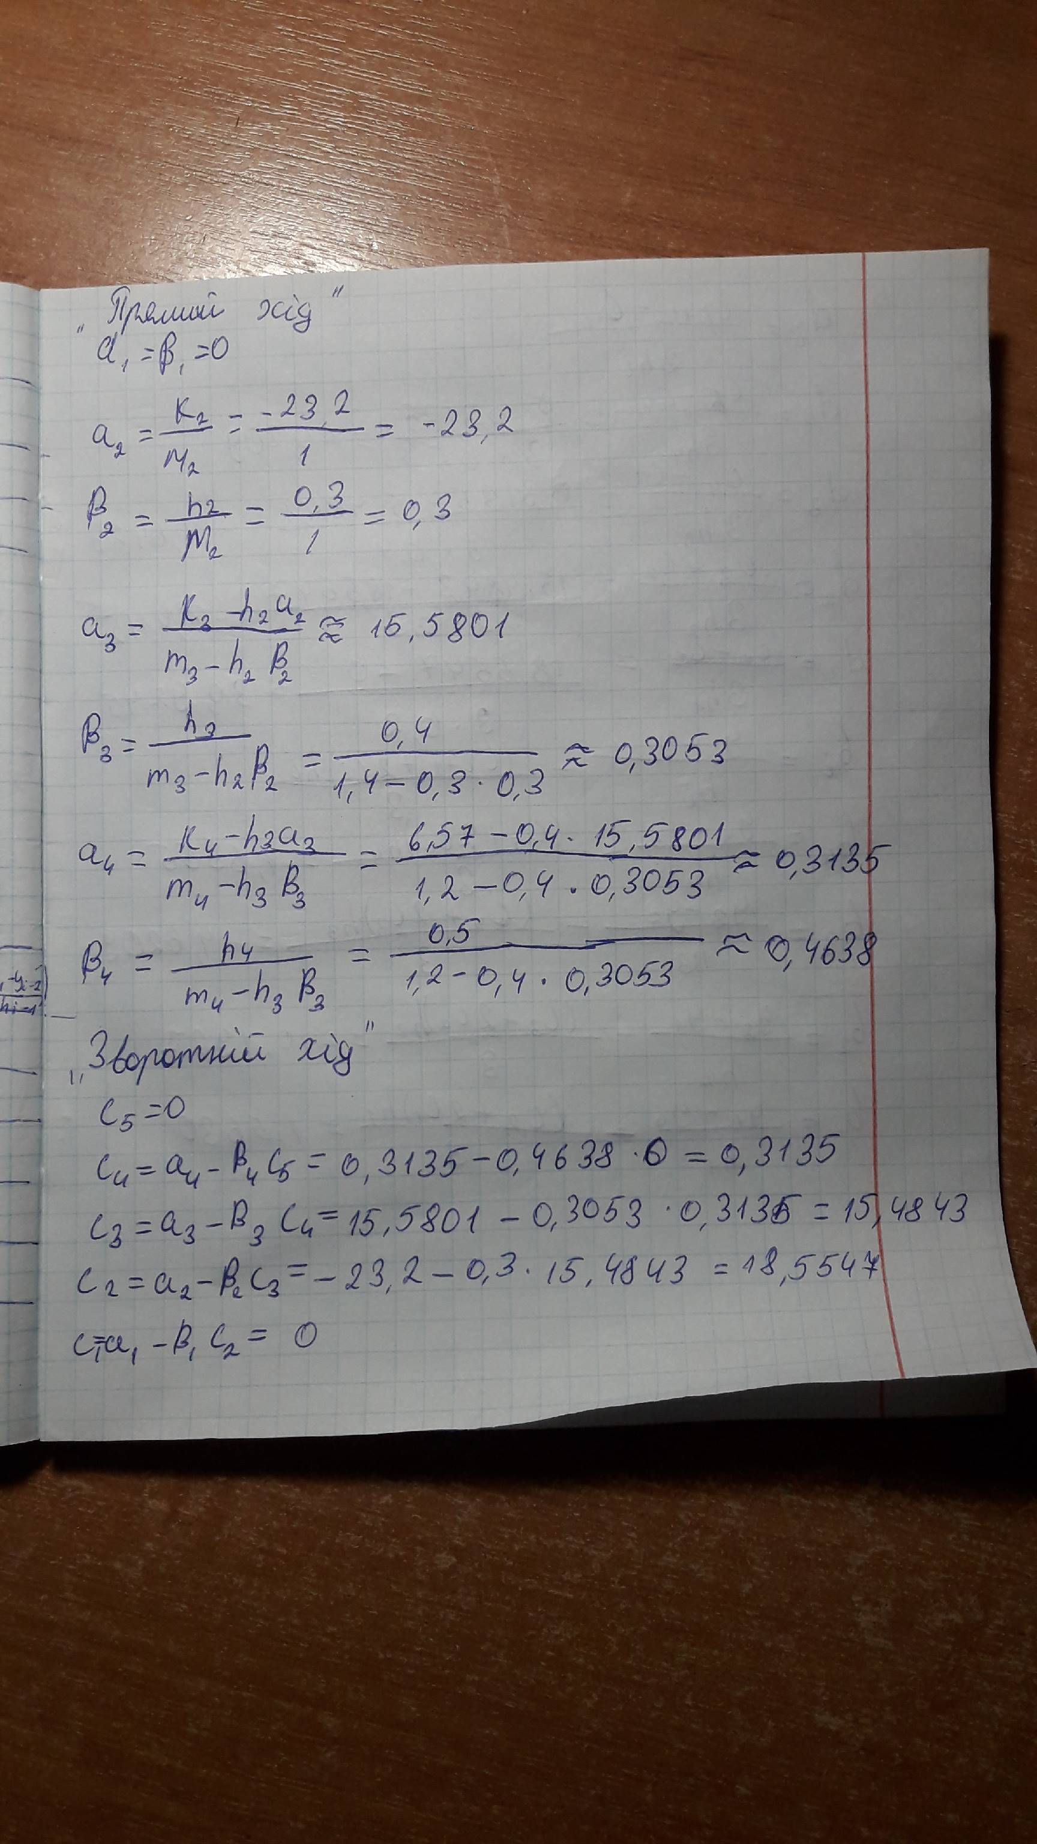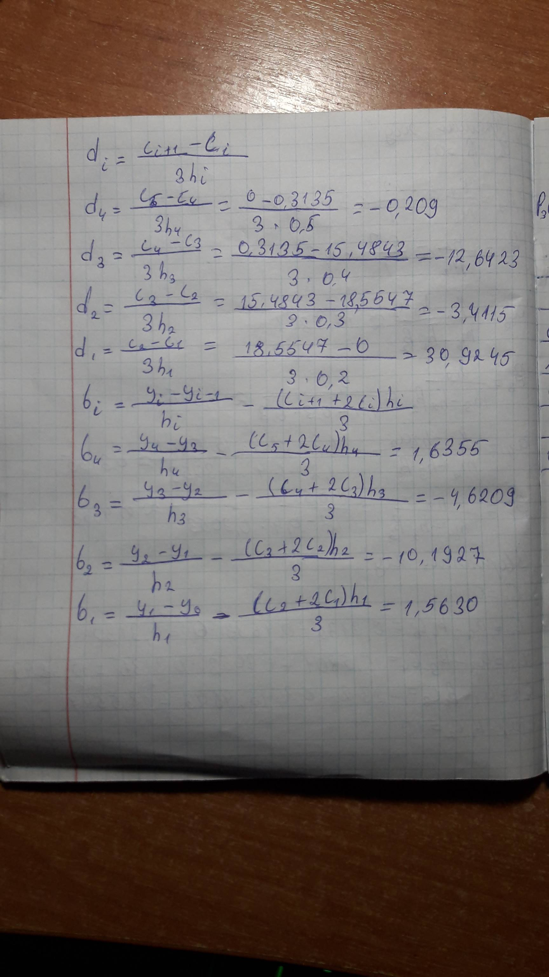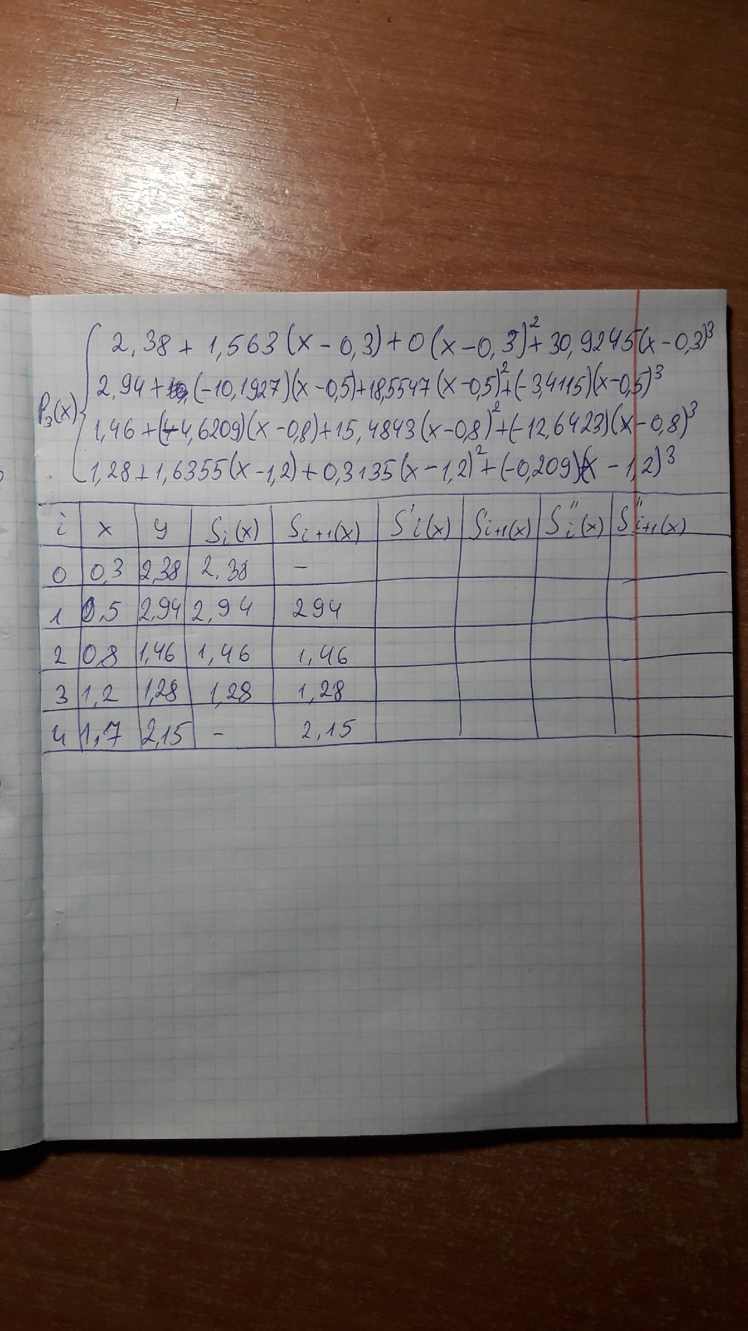

import matplotlib.pyplot as plt

from scipy.interpolate import UnivariateSpline

from numpy import \*

x = [0.3,0.5,0.8,1.2,1.7]

y = [2.38,2.94,1.46,1.28,2.15]

spl = UnivariateSpline(x, y)

xs = linspace(-2, 1.7, 1000)

plt.plot(x,y, "ro", xs, spl(xs), "g")

plt.xlabel("x")

plt.ylabel("y")

plt.title("Histogram")

plt.legend()

plt.grid()

plt.show()